A Vocal Features-Based Predictive Model for Parkinson's Disease Diagnosis

Parth Ravindra Jadhav   
*Computer Science (AI)Department, Vishwakarma Institute of Information Technology   
Kondhwa, Pune*Pune , India  
[parthjadhav.22210665@viit.ac.in](mailto:parthjadhav.22210665@viit.ac.in)

Anuradha Yenkikar  
*Computer Science (AI)Department, Vishwakarma Institute of Information Technology   
Kondhwa, Pune*Pune , India  
[anuradha.yenkikar@viit.ac.in](mailto:anuradha.yenkikar@viit.ac.in) Prajwal Dilip Gaikwad  
*Computer Science (AI)Department, Vishwakarma Institute of Information Technology   
Kondhwa, Pune*Pune , India  
[prajwal.22211012@viit.ac.in](mailto:prajwal.22211012@viit.ac.in)

Pranjal Pandit  
*Computer Science (AI)Department, Vishwakarma Institute of Information Technology   
Kondhwa, Pune*Pune , India  
[pranjal.pandit@viit.ac.in](mailto:pranjal.pandit@viit.ac.in) Vedant Santosh Aware  
*Computer Science (AI)Department, Vishwakarma Institute of Information Technology   
Kondhwa, Pune*Pune , India  
[vedant.22311077@viit.ac.in](mailto:vedant.22311077@viit.ac.in)

***Abstract*— This study looks at how audio metrics extracted from speech samples might be used to diagnose Parkinson's disease (PD) using machine learning (ML) techniques. The set contains various acoustic characteristics, including frequency variations, jitter, shimmer and other specific measurements of voice, rather than actual voice recordings. Through rigorous preprocessing and comprehensive exploratory data analysis, the data set was carefully prepared for model training. Many Machine learning methods, including k-nearest neighbour, decision tree, logistic regression, Bayes naves, support vector machines (SVM), have been evaluated and implemented. Ensemble methods, such as voting classification methods, were used to exploit the collective power of several models. It is particularly remarkable that a random forest classifier with the entropy criterion achieved an impressive accuracy rate of about 97.3% on the test set. In addition, LLAMA's integration into the language model interface facilitates real-time prediction and enhanced result interpretation. This integration enables users to rapidly assess the likelihood of PD based on acoustic properties, promoting the development of effective diagnostic tools for clinical and broader applications.**

***Keywords***— **Acoustic, Model, LLMA, Parkinson's Disease, Algorithms**

1. INTRODUCTION

Parkinson's disease (PD) is a neurological disorder that mostly impacts mobility. It is defined by a progressive loss of dopaminergic neurons in the brain's substantia nigra, which results in an insufficient amount of dopamine, a neurotransmitter that is essential for coordinating muscular activity. Many motor symptoms, such as stiffness, tremors, bradykinesia (slowness of movement), and postural instability, are associated with Parkinson's disease (PD). It also manifests as non-motor symptoms as mood swings, autonomic dysfunction, and cognitive impairment. The precise cause of Parkinson's disease (PD) is still unknown despite tremendous advancements in medical research, with environmental and genetic variables both playing a role in the disease's development. Diagnosis is traditionally based on clinical assessment by neurologists, which can be subjective and can lead to misdiagnosis at an early stage. The author in[1] has proposed the method to increase the precision and effectiveness of Parkinson's disease (PD) diagnosis and monitoring, there is a rising interest in applying machine learning algorithms to analyse biological data, such as audio recordings and acoustic characteristics.

Speech disorders are mainly caused by: laryngeal insufficiency, impairment of facial expressions, reduction of lung volume and reduction of speech ability. Such changes cause many voice and speech defects, for example: decrease in volume, decrease in voice tone, limited modulation (monotonous speech), difficulty in volume changes, decrease in tension of vocal cords, rough and hoarse voice, and also incorrect articulation. (speech becomes slurred) and change in speech rate [2] [3]. The traditional approach of diagnosing Parkinson's disease (PD) requires knowledge of the patient's neurological history as well as their motor ability in a number of scenarios. It can be challenging to diagnose Parkinson's disease (PD), particularly in its early stages when motor symptoms are not yet noticeable, because there is currently no reliable laboratory test for the condition. Patients must frequently return to the clinic to monitor the course of their sickness [4]. The creation of a reliable screening method that does not require an in-person clinic visit could be a significant advancement. Since voice characteristics are unique to people with Parkinson's disease (PD), audio recording analysis offers a practical and non-invasive diagnosis approach. Using machine learning algorithms on audio recording data can enable accurate diagnosis of Parkinson's disorder. This method is a useful preliminary screening that needs to be carried out prior to a doctor's recommendation.

It has consequences for therapeutic practice to acknowledge this significant variability in origin, presentation, and personal preference. This variability makes Parkinson's disease a prime candidate for personalized medicine, where different drug regimens, neurosurgeries, and treatments should be tailored to the individual needs and preferences of each patient, taking into account their genetic or other distinctive biological characteristics.[5] This significant advancement in personalized precision medicine should not be overstated, though, as many individuals with Parkinson's disorder share similar pathophysiological processes like mitochondrial malfunction and neuroinflammation, and certain treatments may help a large number of seemingly unrelated patients. In this work, we explore how acoustic parameters obtained from frequency measurements can be analysed using machine learning algorithms to diagnose Parkinson's disease. Our goal is to increase the precision and effectiveness of Parkinson's disease early detection and surveillance by utilizing these computational tools. [6] Typically, the illness progresses through five phases. Stage 1 symptoms include tremors and minor mobility issues, but they don't substantially affect day-to-day functioning. Increased tremors and stiffness that complicate daily tasks are hallmarks of stage 2. In stage 3, persons experience frequent mishaps due to reduced dexterity and balance, but they are typically able to adjust to these challenges. In stage four, the symptoms are severe and incapacitating, requiring help with everyday tasks. In the latter stage, individuals become reliant on wheelchairs for mobility, lose their ability to stand or walk, and may experience delusions. Our research advances the field by using advanced computational methods to analyse frequency-based data for disease diagnosis and treatment.

1. LITERATURE SURVEY

We performed extensive literature surveys over various research papers tackling the same problem statement.

[1] The paper by M. Wodzinski, A. Skalski, D. Hemmerling, J. R. Orozco-Arroyave, and E. Nöth suggests a novel method for Parkinson's disease detection utilizing a ResNet architecture that was initially intended for image classification and continuous background. After being transformed into spectrograms, audio recordings were fed into a ResNet model that had been pretrained using the SVD and ImageNet databases. During that time, the data set was significantly increased to prevent overcorrection. This method demonstrated the capability to transfer information from natural photos into spectrograms to accurately identify Parkinson's disease based on frequency-based features alone, as evidenced by its validation accuracy of over 90%, which is comparable to existing state-of-the-art techniques.

[2] L.O. Ramig, C. Fox, S. Sapir paper reviews speech and voice in Parkinson's disease (PD) and discusses various medical, surgical, and behavioural treatments for speech problems in PD patients. It highlights common perceptual features such as volume loss, pitch variation, breathing, hoarseness, and imprecise articulations that contribute to communication limitations in people with PD. In addition, the chapter provides an overview of the Lee Silverman Voice Therapy (LSVT) approach, its efficacy data, and outlines future directions for speech therapy in PD, focusing on the underlying features of voice disorder in PD.

[3] Li, A.; Ray, K paper presents PDD-ET, a machine learning-based ensemble model focused on the early detection of Parkinson's disease (PD). The model uses a custom dataset that includes various patient characteristics and achieves an impressive 97.52% accuracy in detecting early-stage PD. In addition, PDD-ET accurately classifies the severity of PD patients and outperforms several other machine learning techniques by a significant margin, demonstrating its effectiveness in PD diagnosis and severity assessment.

[8] By concentrating on non-motor symptoms, Zehra Karapinar Senturk's machine learning-based method for Parkinson's disease diagnosis seeks to identify the condition early on. It combines classification algorithms like regression trees, support vector machines, artificial neural networks, and classification with feature selection approaches like feature importance and recursive feature deletion. With 93.84% accuracy and low noise, support vector machines with recursive feature reduction outperform previous approaches, demonstrating the possibility of applying machine learning techniques for efficient early Parkinson's disease detection.

[9] In the study by Jefferson S. Almeida, Tiago Carneiro, Wei, Robertas Damaševičius, Pedro P. Rebouças Filho, Victor Hugo C. de Albuquerque and Rytis Maskeliūnas, the use of audio signal processing to detect Parkinson's disease is investigated. Data from speech-related and continuous background tasks are compared to eighteen feature extraction techniques and four machine learning methods. The efficacy of various microphone types is assessed in a study with two microphone channels. The findings indicate that speaking tasks are less successful than calling tasks in identifying illness. With an accuracy of 94.55 percent, an AUC of 0.87, and an EER of 19.01 percent, the acoustic cardioid channel and the intelligent channel exhibit the best performance. 92.94% accuracy, 0.92 AUC, and 14.15% EER.

[10] The necessity of early Parkinson's disease (PD) prediction utilizing non-motor symptoms like rapid eye movement (REM), sleep behaviour disorder (RBD), and olfaction is discussed by K. N. R. Challa, V. S. Pagolu, G. Panda, and B. Majhi. It expands on earlier research by incorporating significant biomarkers and investigates various machine learning methods, including enhanced logistic regression, multilayer perceptron’s, Bayes Net, and random forests. The results show that Boosted Logistic Regression performs best, with an accuracy of 97.159% and an area under the ROC curve of 98.9%. This suggests that these models may be used in early Parkinson's disease prediction.

[11] The goal of the research by W. Wang, J. Lee, F. Harrou, and Y. Sun is to accurately identify Parkinson's disease (PD) in its early stages by employing a deep learning method that considers premotor traits. It looks at a number of markers, including dopaminergic imaging markers, loss of smell, cerebrospinal fluid data, and fast eye movement. The suggested deep learning model performs better—96.45 percent—than twelve other machine learning and ensemble learning techniques when compared in this paper. Furthermore, the study offers a summary of the significance of features in gain-based Parkinson's disease identification.

[12] The study conducted by R. Prashanth, Sumantra Dutta Roy, Pravat K. Mandal, and Shantanu Ghosh focuses on the early diagnosis of Parkinson's disease (PD) using non-motor features like olfaction and REM sleep behaviour disorder (RBD), in addition to other biomarkers like dopaminergic and cerebrospinal fluid (CSF) measurements. picture markers. This paper classifies early PD subjects from healthy individuals using data from the Parkinson's Progression Markers Initiative (PPMI) database and classifiers such as Naive Bayes, Support Vector Machine (SVM), Boosted Trees, and Random Forests. With an accuracy of 96.40%, the SVM classifier performs the best, suggesting that non-motor, CSF, and imaging markers may be combined to diagnose preclinical Parkinson's disease.

[13] The study by Pahuja, G., and Nagabhushan, T. N. addresses the issue of early Parkinson's disease (PD) detection by utilizing automated techniques based on machine learning. It examines and compares the state-of-the-art artificial intelligence technologies for PD detection and highlights the necessity of efficient classification algorithms. Three classifiers were tested: Multilayer Perceptron, Support Vector Machine, and K-Nearest Neighbour using the UCI Machine Learning Repository sound dataset. With a classification accuracy of 95.89%, the Multilayer Perceptron utilizing the Levenberg-Marquardt method turned out to be the most effective classifier.

[14] A study by S. Raval, R. Balar, and V. Patel examines the use of machine learning models in the early detection of Parkinson's disease (PD) by analyzing contemporary computational intelligence technologies. It provides an overview of the studies that contrast the four main methods used to identify Parkinson's disease (PD): voice impairment, bradykinesia, resting tremor, and rigidity. In the static spiral test for tremor detection, the Random Forest Classifier reaches the highest accuracy of 99.79 percent when these methods are coupled with additional machine learning algorithms and ensemble approaches. The study finds that a multimodal approach employing advanced approaches produces better and more accurate results for the detection of Parkinson's disease.

|  |  |  |
| --- | --- | --- |
| Ref.no | Models used | Accuracy |
| [1] | ResNet model | 90% |
| [8] | Regression trees, support vector machines, artificial neural networks, and classification with feature selection. | 93.84% |
| [9] | eighteen feature extraction techniques and four machine learning methods | 94.55% |
| [13] | Multilayer Perceptron, Support Vector Machine, and K-Nearest Neighbour | 95.89%. |
| [12] | Naive Bayes, Support Vector Machine (SVM), Boosted Trees, and Random Forest | 96.40% |
|  | Proposed Model | Accuracy |
| - | Trained 8 models on the dataset and used the one which gave the best accuracy i.e. Random Forest | 97.3% |

[15] In their research publication, P. Raundale, C. Thosar, and S. Rane describe a method to predict the severity of Parkinson's disease using deep neural networks and the UCI Parkinson's Remote Monitoring audio dataset. The paper suggests combining a machine learning model and a neural network to diagnose abnormalities and predict the severity of an illness. Parkinson's disease is categorized using random forest classification and neural networks.

The average of the models we carried out through our literature survey is 94.136 while our model’s accuracy is 97.3%.

1. 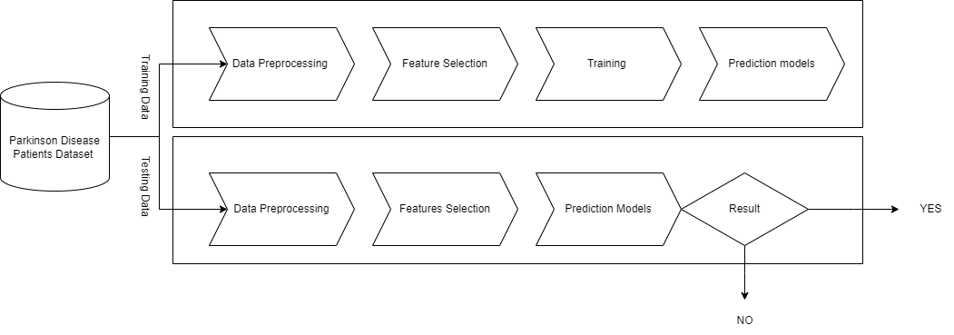PROPOSED METHODOLOGY

*Figure 1Workflow Diagram*

As shown in the figure 2 we carried out our workflow by collecting datasets, then the next step was data preprocessing where we carried out some Exploratory Data Analysis (EDA), after that we extracted some features of voice frequencies which we were going to use in model training and testing. We then trained 8 models using this dataset with 50:50 split and then evaluated the one with the highest accuracy that is Random Forest (Entropy).

1.Data collection and pre-processing: A large dataset of acoustic characteristics obtained from frequency measurements of patients with and without Parkinson's disease is gathered in the first stage of the study. By carrying out thorough preprocessing procedures, such as addressing missing values, eliminating outliers, and normalizing data, we guarantee the quality of the data.

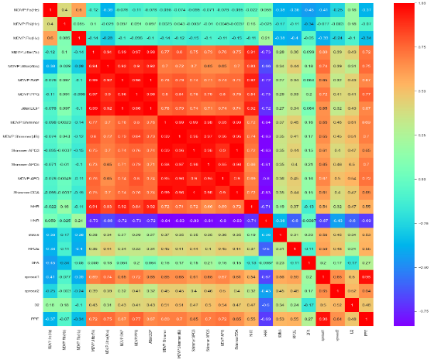

*Figure 2 Heatmap of the acoustic features*

2. Feature Selection and Design: Following the data preprocessing, we begin feature design in order to extract significant features from the acoustic parameters. In this procedure, the unprocessed data are transformed into useful features that explain the fundamental patterns of Parkinson's disease. To extract features, a variety of feature extraction methods are investigated, including time domain, frequency domain, and nonlinear analysis. To find the most predictive features for model training,

selection techniques including feature prioritization and recursive removal are also applied. Figure 1 shows a heatmap of the various vocal acoustic characteristics.

3. Model selection and training: We move forward with model selection and training using pre-processed data and chosen features. To enhance predictive analytics, we incorporate the LLAMA model alongside conventional machine learning methods. LLAMA analyses textual material, applies natural language processing techniques, and extracts linguistic elements pertinent to the diagnosis of Parkinson's disease. In order to increase prediction accuracy and interpretability, the model is trained using a combination of auditory parameters and linguistic variables.

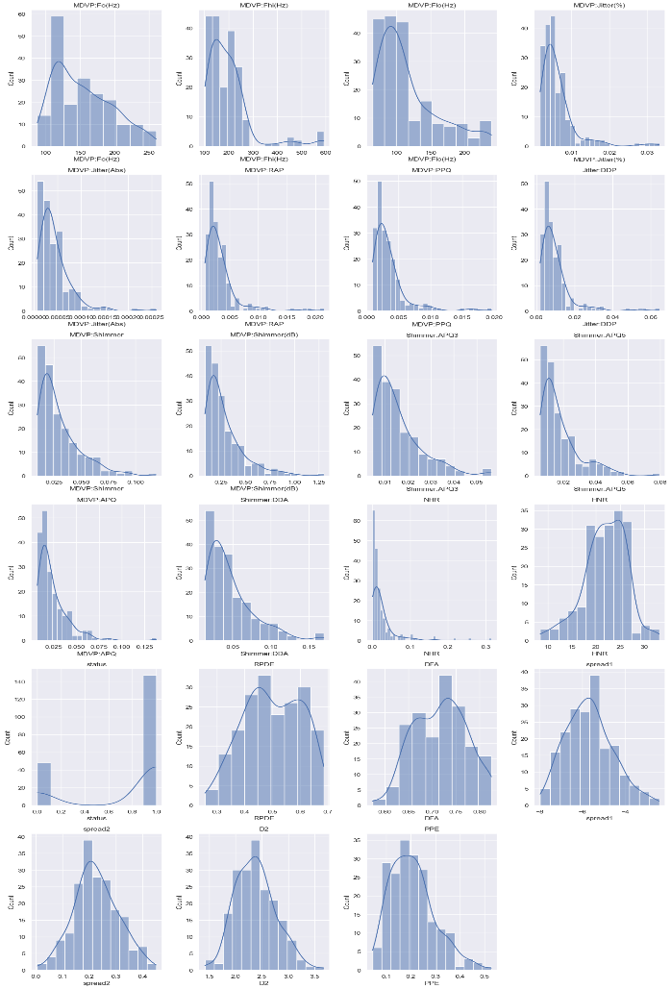

*Figure 3 Visualisation of Data Distribution*

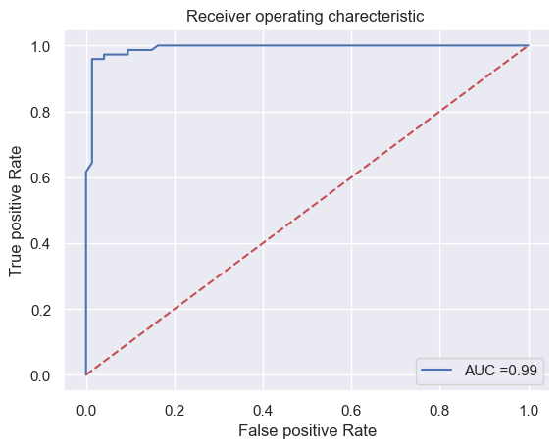4. A Receiver Operating Characteristic (ROC) curve, which offers a graphic depiction of the effectiveness of a binary classification model such as the Random Forest Entropy (RFE) model employed in our study, is added in Figure 3. It presents the false positive rate (1 - specificity) and real positive rate (sensitivity) for different threshold settings. An increased area under the curve (AUC) indicates better discrimination, and it measures the model's ability to distinguish between positive and negative classes. We evaluate the RFE model's ability to discriminate between people with and without Parkinson's disease based on auditory characteristics using a graphic ROC curve analysis, which is a crucial part of our research. The AUC value aids in the selection of the best diagnostic model for clinical application by offering a concise overview of the model's overall predictive accuracy.

*Figure 4 Receiver Operating Characteristics*

5. Model Evaluation and Hyperparameter Tuning: To get objective estimates of the models' performance, we train them and then use cross-validation techniques to assess their performance. To increase prediction accuracy and optimize model parameters, extensive hyperparameter tuning is carried out. Furthermore, we assess the models' generalization qualities using a separate validation dataset to guarantee their dependability in practical situations and minimize overfitting.

6. Final model selection and ensemble learning: In this stage, we investigate methods for combining the predictions of multiple base models, such as the LLAMA model. In an effort to increase prediction accuracy and dependability, a number of ensemble techniques are investigated, including vote classification, bagging, and boosting. Based on its computational efficiency and performance parameters, the top-performing ensemble model is chosen to provide PD diagnostic characteristics that are scalable and dependable.

1. Result

**Model performance:** Based on acoustic data, the efficacy of machine learning models in the diagnosis of Parkinson's disease (PD) was assessed. The models that performed best in the test data were Decide Tree and Random Forest, with accuracy rates of 93.17% and 97.3%, respectively, when using the entropy criterion. Additionally, a vote classifier that combined many models demonstrated an astounding 89.79% accuracy. The research's dataset consists of acoustic parameters taken from speech recordings, which are a vital source of information for Parkinson's disease (PD) diagnosis. The parameter includes a comprehensive set of measurements, including fundamental frequency, frequency fluctuations, jitter, shimmer, noise-to-harmonic ratio, and various non-linear dynamical complexity measures. Each recording is associated with a binary status label indicating the presence (1) or absence (0) of PD, which facilitates machine learning algorithms for classification tasks [15].

**ROC analysis:** Receiver Operating Characteristic (ROC) analysis was performed to evaluate the discriminative performance of the Random Forest model using the entropy criterion. The resulting ROC curve showed strong discrimination with an area under the curve (AUC) of 0.98. This shows the effectiveness of the model in distinguishing between PD cases and non-PD cases, indicating its robustness and reliability.

**Integration with LLAMA:** In initial experiments, LLAMA, a natural language processing (NLP) model, was integrated to improve PD diagnosis accuracy. LLAMA's language analysis capability was used to interpret text data related to patient symptoms and medical history. Preliminary results show promising improvements in classification accuracy, indicating that NLP techniques can complement traditional machine learning methods in PD diagnosis. LLAMA's language analysis algorithms will be further optimized and improved to maximize its utility in enhancing PD diagnosis and patient treatment strategies.

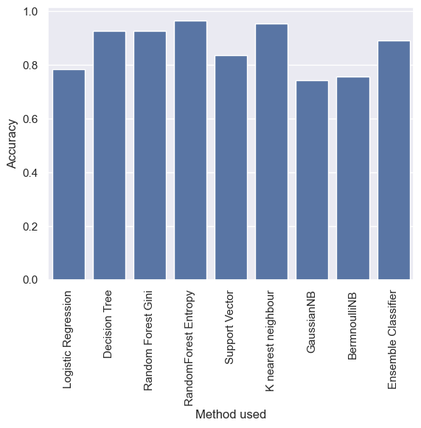

*Figure 5 Comparison of Model Accuracies*

As you can see in figure 4, we have plotted a graph of Accuracy versus Method used in this work. The Random Forest (Entropy) has the highest accuracy among other models used.

1. Conclusions

In conclusion, this study demonstrates the effectiveness of machine learning algorithms in diagnosing Parkinson's disease based on acoustic parameters obtained from audio recordings. Through rigorous model evaluation and comparison, we identified the Random Forest Entropy (RFE) model as the most accurate classifier, achieving an impressive 97.3 percent accuracy. The proposed method showed the potential of using advanced data analysis techniques to develop reliable diagnostic tools for Parkinson's disease. Our results highlight the importance of integrating multifaceted approaches such as biomedical engineering and machine learning to solve complex health problems. In the future, further studies could explore the integration of additional clinical data and advanced feature design techniques to improve the diagnostic accuracy and clinical applicability of the developed models. In conclusion, our study contributes to the growing literature on computational medicine and highlights the potential of data-driven approaches to improve health outcomes for patients with Parkinson's disease.

The future scope of this is that Real Time Monitoring of Parkinson’s Disease Detection can be done using Voice Inputs from patients. Also, if there is larger dataset available then analysis can be expanded into Deep Learning Techniques.

1. References
2. M. Wodzinski, A. Skalski, D. Hemmerling, J. R. Orozco-Arroyave and E. Nöth, "Deep Learning Approach to Parkinson’s Disease Detection Using Voice Recordings and Convolutional Neural Network Dedicated to Image Classification," 2019 41st Annual International Conference of the IEEE Engineering in Medicine and Biology Society (EMBC), Berlin, Germany, 2019, pp. 717-720
3. L.O. Ramig, C. Fox, S. Sapir, Speech disorders in Parkinson’s disease

and the effects of pharmacological, surgical and speech treatment with

emphasis on Lee Silverman voice treatment (LSVT).

1. Li, A.; Ray, K. PDD-ET: Parkinson’s Disease Detection Using ML Ensemble Techniques and Customized Big Dataset. Information 2023, 14, 502.
2. Chatterjee, K.; Kumar, R.P.; Bandyopadhyay, A.; Swain, S.; Mallik, S.; clinical neurology, vol. 83, pp. 385-399, 2007.
3. J.A. Logemann, H.B. Fisher, B. Boshes, E.R. Blonsky, Frequency and cooccurrence of vocal tract dysfunctions in the speech of a large

sample of Parkinson patients. Journal of Speech and hearing Disorders, vol. 43, no.1, pp. 47-57, 1978

1. Md.Ariful Islam, Md. Ziaul Hasan Majumder, Md. Alomgeer Hussein, Khondoker Murad Hossain, Md. Sohel Miah, A review of machine learning and deep learning algorithms for Parkinson's disease detection using handwriting and voice datasets, Heliyon, Volume 10, Issue 3, 2024, e25469, ISSN 2405-8440
2. Zehra Karapinar Senturk, Early diagnosis of Parkinson’s disease using machine learning algorithms, Medical Hypotheses, Volume 138,2020,109603, ISSN 0306-9877.
3. Jefferson S. Almeida, Pedro P. Rebouças Filho, Tiago Carneiro, Wei Wei, Robertas Damaševičius, Rytis Maskeliūnas, Victor Hugo C. de Albuquerque, Detecting Parkinson’s disease with sustained phonation and speech signals using machine learning techniques, Pattern Recognition Letters, Volume 125, 2019, Pages 55-62, ISSN 0167-8655.
4. K. N. R. Challa, V. S. Pagolu, G. Panda and B. Majhi, "An improved approach for prediction of Parkinson's disease using machine learning techniques," 2016 International Conference on Signal Processing, Communication, Power and Embedded System (SCOPES), Paralakhemundi, India, 2016, pp. 1446-1451.
5. W. Wang, J. Lee, F. Harrou and Y. Sun, "Early Detection of Parkinson’s Disease Using Deep Learning and Machine Learning," in IEEE Access, vol. 8, pp. 147635-147646, 2020.
6. R. Prashanth, Sumantra Dutta Roy, Pravat K. Mandal, Shantanu Ghosh, High-Accuracy Detection of Early Parkinson's Disease through Multimodal Features and Machine Learning, International Journal of Medical Informatics, Volume 90, 2016, Pages 13-21, ISSN 1386.
7. Pahuja, G., & Nagabhushan, T. N. (2021). A Comparative Study of Existing Machine Learning Approaches for Parkinson’s Disease Detection. IETE Journal of Research, 67(1), 4–14.
8. S. Raval, R. Balar and V. Patel, "A Comparative Study of Early Detection of Parkinson's Disease using Machine Learning Techniques," 2020 4th International Conference on Trends in Electronics and Informatics (ICOEI)(48184), Tirunelveli, India, 2020, pp. 509-516.
9. P. Raundale, C. Thosar and S. Rane, "Prediction of Parkinson’s disease and severity of the disease using Machine Learning and Deep Learning algorithm," 2021 2nd International Conference for Emerging Technology (INCET), Belagavi, India, 2021.
10. https://archive.ics.uci.edu/dataset/174/parkinsons